**FOUR STAHE PIPELINE USING C**

**AIM:**

To write a C program to implement Four stage pipeline using C.  
  
  
  
  
  
**ALGORITHM:**  
  
  
1)      Store  
the remainder when the number is divided by 8 in an array.  
  
  
2)      Divide  
the number by 8 now  
  
  
3)      Repeat  
the above two steps until the number is not equal to 0.  
  
  
4)      Print  
the array in reverse order now.

**PROGRAM:**

#include<stdio.h>

int main(){

int counter=0;

int input;

int num1,num2;

int op;

int res;

int ins;

int performance_measure=0;

printf("\n Enter 1st value:");

scanf("%d",&num1);

counter+=1;

printf("\n Enter the 2nd value: ");

scanf("%d",&num2);

counter+=1;

printf("\n Enter the option: \n1)Addition\n2)Subraction\n3)Multiplication\n4)Division");

scanf("%d",&op);

switch(op){

case 1:

printf("Performing addition operation\n");

res=num1+num2;

counter+=1;

break;

case 2:

printf("Performing subraction operation\n");

res=num1-num2;

counter+=1;

break;

case 3:

printf("Performing multiplication operation");

res=num1*num2;

counter+=1;

break;

case 4:

if(num2==0){

printf("\n Denominator can't be zero");

}

else{

printf("Performing division operation");

res=num1/num2;

counter+=1;

break;

}

default:

printf("Invalid case...");

counter+=3;

break;

}

printf("\n CYCLE VALUE IS : %d",counter);

printf("\nEnter the no.instruction");

scanf("%d",&ins);

performance_measure=ins/counter;

printf("\n Performance Measure is: %d",performance_measure);

}

**INPUT & OUTPUT:**

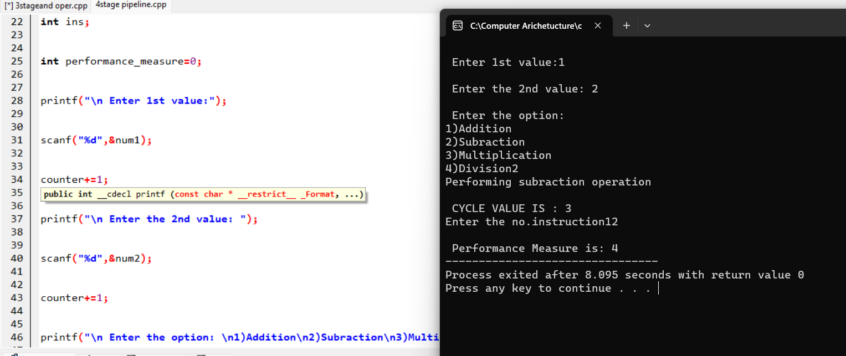

**RESULT:**

Thus we can write the program Four stage pipelining in DEV C++.